User Instructions: CCSD Labor Burden Worksheet

Purpose & Scope:
This document provides instructions for downloading and completing the Clark County School District (CCSD) Construction Management Labor Burden Worksheet. It applies to all contractors and subcontractors submitting labor burden and prevailing wage calculations for CCSD facility projects.
Procedures:
1. Access & Template Selection
- Portal Navigation: Visit the CCSD Construction Management Documents portal at https://cm.ccsd.net/documents.
- Search: In the Search Document by Name bar, type “labor burden”.
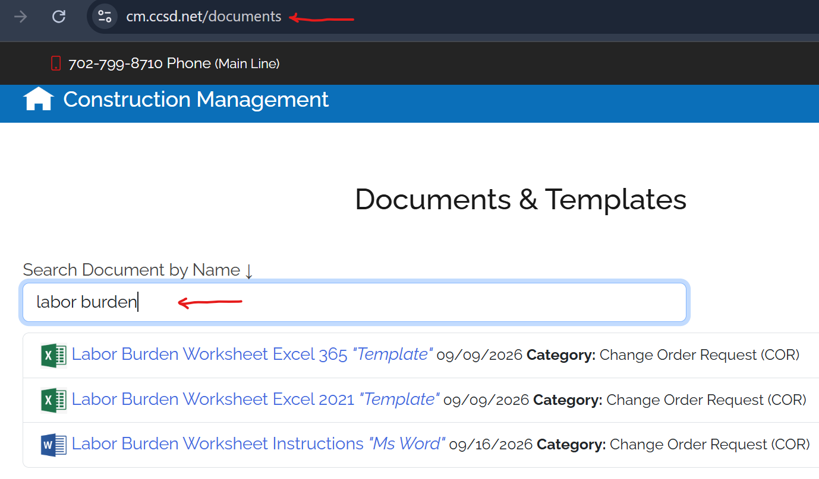
- Version Selection: Select and download the Excel file that matches your software version:
  - Labor Burden Worksheet Excel 365
  - Labor Burden Worksheet Excel 2021
It is advisable to refer to the Labor Burden Worksheet Instructions (MS Word file) for guidance.
The Labor Burden Worksheet Excel forms are subject to periodical revisions. Users are encouraged to visit the website and download the most current template.

2. Data Entry Rules & Field Guidelines
CRITICAL RULE: Enter data ONLY into light-blue shaded cells. Yellow shaded cells contain automated formulas and must not be edited or overwritten.

2.1 Project & Worker Information
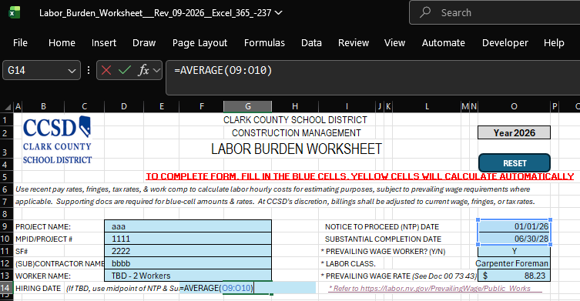
- Project Details: Enter the Project Name, MPID/Project #, SF#, (Sub)contractor Name, Notice to Proceed (NTP) Date and Substantial Completion Date. The MPID#, SF#, NTP Date, and Substantial Completion Date can be obtained from the general contractor or CCSD Project Manager.
- Worker Name & Hiring Date:
  - Complete a separate form for each worker who will work on the project. The worksheet will calculate costs accordingly based on each individual's hire date.
  - If the worker has not yet been identified (TBD), complete one form for each applicable job classification. Enter a hire date equal to the midpoint between the NTP Date and the Substantial Completion Date. Use Excel's =AVERAGE(...) formula, referencing the cells containing those two dates. In the blue “Worker Name” cell, enter “TBD – 1 Worker”, “TBD – 2 Workers”, etc.
- All three dates, Hiring Date, NTP Date, and Substantial Completion Date, are required for labor cost calculations. Missing any of these dates will cause errors.
- Labor Classification & Prevailing Wage Rate: Indicate if the worker is a Prevailing Wage Worker (Y/N). If yes, check Contract Doc 00 73 43 for the applicable effective period and visit https://labor.nv.gov/PrevailingWage/ for the appropriate Labor Class and required Prevailing Wage Rate.
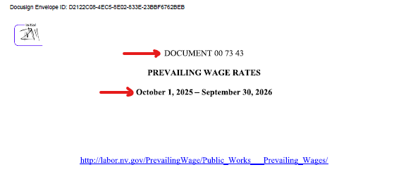

2.2 Wage & Fringe Breakdown
- Wages (Per Hour): Input the Base Hourly Rate, Zone Rate (if applicable), and any Other Taxable Rates into the designated blue cells.
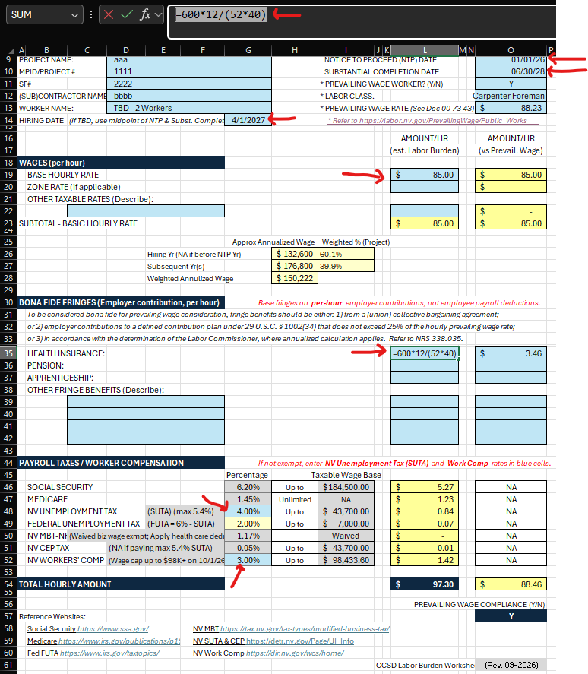
- Bona Fide Fringes (Employer Contribution Per Hour):
  - To qualify as bona fide fringe benefits for prevailing wage consideration, benefits should be either: 1) from a (union) collective bargaining agreement; or 2) employer contributions to a defined contribution plan (under 29 U.S.C. § 1002(34) that does not exceed 25% of the hourly prevailing wage rate; or 3) in accordance with the determination of the Labor Commissioner. Refer to NRS 338.035.
  - Enter hourly employer contributions for Health Insurance, Pension, Apprenticeship, and applicable Other Fringe Benefits. Under NRS 338.035(2), annualized calculations apply. For example, the monthly health insurance premium for a union worker is $1,000 where the company contributes $600 and the employee pays $400. The hourly employer contribution is calculated as: $600/m x 12 months / (52 weeks x weekly work hours).
- Payroll Taxes / Workers’ Compensation: If not exempt, enter applicable percentage rates in the blue cells for NV Unemployment Tax (SUTA) (max 5.4%) and NV Workers' Comp. The other payroll taxes rates and taxable wage bases are pre-populated in the worksheet formulas. Refer to the government websites listed at the bottom of the worksheet for information on these tax requirements and structures.
3. Resetting the Form
- To clear all input fields and restart the form for another worker, click the blue RESET button located in the top-right corner of the worksheet. It will clear data entered in the blue cells while retaining the underlying worksheet formulas.
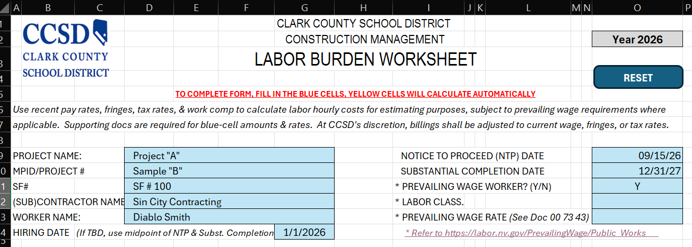

Supporting Documents:
Supporting documentation is required for the hiring date, amounts, and rates entered in the blue cells. Examples of acceptable supporting documentation include:
- Hiring Date: No supporting documentation is required if the worker was hired on or before January 1 of the NTP year. Otherwise, provide an employment agreement or other HR documentation verifying the worker's hire date.
- Hourly Pay Rates: Recent pay stubs for similar government projects.
- Health Insurance: Monthly statements from the health insurance provider showing the breakdown of employer and employee contributions.
- NV Unemployment Tax (SUTA): Notice of Employer's Contribution Rate Statement sent each December by the Nevada Department of Employment, Training, and Rehabilitation (DETR).

